AI-Powered Skin Cancer Classification: A VGG-19 and Feature Optimization Approach

N. Neeraj Emanuel   
*Dept. of IST*  
*CEG*Chennai, India  
neerajemanuel@gmail.com

A. Sujith  
*Dept. of IST*  
*CEG*Chennai, India  
sujith@gmail.com

Vishnu Prasadh  
*Dept. of IST*  
*CEG*Chennai, India  
vishnuprasadh@gmail.com

*Abstract*—Skin cancer is a malignancy that develops in the skin cells, with the primary types being Basal Cell Carcinoma (BCC), Squamous Cell Carcinoma (SCC), and Melanoma. It is often triggered by excessive exposure to ultraviolet (UV) radiation from the sun or tanning devices. Early symptoms include changes in existing moles or the appearance of unusual growths. Prevention focuses on minimizing sun exposure, while treatment options range from surgery to targeted therapies depending on the cancer type and stage. To overcome these issues, this project proposes a study on the spectrum of UV-induced DNA damage in melanoma: insights from AI-based analysis of environmental factors, repair mechanisms, and skin pigment interactions. The methodology begins with preprocessing steps that utilize an Adaptive Median Filter to enhance image quality and reduce noise, ensuring that relevant features are preserved for analysis. Following preprocessing, thresholding is applied to ensure simplicity and efficiency in the images, thereby improving the effectiveness of segmentation for the classification model. VGG19 is employed to extract features and classify the images, providing improved accuracy compared to traditional methods. Flask is used to deploy the VGG-19 model for real-time skin disease detection. It handles input images, processes them through preprocessing, segmentation, and feature extraction, and delivers the predicted output efficiently, ensuring seamless user interaction. Additionally, the Gray Level Co-occurrence Matrix (GLCM) is used for feature extraction, further enhancing texture analysis for the model input. The proposed framework aims to automate the diagnostic process, reducing the reliance on manual interpretation by radiologists. Experimental results demonstrate the effectiveness of this approach in accurately identifying and classifying skin diseases, contributing to timely and efficient patient care. This project is implemented using the Python programming language.

Keywords—GLCM, VGG, deep learning, CNN, segmentation, thresholding

# Introduction

Skin cancer is the abnormal growth of skin cells, primarily categorized into Basal Cell Carcinoma (BCC), Squamous Cell Carcinoma (SCC), and Melanoma**.** Among these, melanoma is the most aggressive type, with a high tendency to spread to different parts of the body if not detected early. The primary cause of skin cancer is prolonged exposure to ultraviolet (UV) radiation from the sun or tanning devices. Other risk factors include fair skin, genetic predisposition, a weakened immune system and frequent sunburns. Traditional diagnostic methods involve multiple consultations, biopsies, **and laboratory tests**, making early detection **slow, costly and resource-intensive**. In many rural and underserved areas, the lack of trained dermatologists **delays diagnosis and treatment**, increasing the risk of cancer progression. Furthermore, **the similarity between benign and malignant skin lesions** makes accurate detection challenging, often leading to **false positives or false negatives** that delay proper treatment. To address these challenges, this project explores **AI-powered analysis of UV-induced DNA damage in melanoma**, focusing on **environmental factors, DNA repair mechanisms, and skin pigment interactions**. Since **melanoma spreads rapidly**, early detection is critical to improving patient outcomes. Preventative measures such as **limiting sun exposure, wearing protective clothing, and conducting regular skin self-examinations** are essential in reducing the risk of skin cancer.

A **computer-aided diagnostic system** improve early melanoma detection by analyzing skin lesion images without requiring invasive procedures. Since skin cancer originates in the **epidermis (the outermost skin layer)**, it is **highly visible**, making image-based AI models effective for preliminary diagnosis. However, unwanted artifacts such as **hairs, gel bubbles, clinical ruler marks and charts** interfere with melanoma segmentation. Removing these artifacts enhances the accuracy of skin cancer classification, allowing for **efficient and precise detection** of malignant lesions. With **early diagnosis and skin lesion analysis**, the alarming mortality rate of melanoma be significantly reduced, offering **a cost-effective and accessible solution** for skin cancer detection worldwide. Late diagnosis of melanoma leads to the severe malignancy of disease and metastasis expands to the other body organs i.e. liver, lungs and brain. The dermatologists analyze the pigmented lesions over the skin to discriminate melanoma from other skin diseases. In reality, a person with melanoma dies every 57 seconds. When cancer is detected in dermoscopy images in advance, the survival percentage is significantly boosted. Skin cancer early detection is still a prized possession.  According to estimates from the World Health Organization, there are between two to three million new cases of skin cancer annually. Despite advancements in treatment, the 5-year survival rate for skin cancer patients starts from almost 100% survivability in the early stages and drops to approximately 25-35% in the latest stages of all skin cancer-related deaths. It’s difficult to tell if a skin lesion is benign or malignant because they all seem similar. The sun’s harmful ultraviolet (UV) rays and the usage of UV tanning beds are the two most common causes of skin cancer. It is particularly difficult for dermatologists to distinguish between melanoma and non-melanoma lesions because of the low degree of difference between lesions and skin.

These genetic changes accumulate over time as a result of UV-induced DNA damage to melanocytes, turning normal cells into malignant melanoma cells. This study explores the incorporation of ultraviolet (UV) radiation, DNA damage, UV signature mutations, skin pigmentation, melanin biochemistry and gene-environment interactions into AI-powered melanoma identification systems. Skin cancer is one of the most common types of cancer worldwide, and early detection is crucial for successful treatment. Skin cancer is a leading cause of morbidity and mortality worldwide, making early and accurate detection essential for improving patient outcomes. In recent years, **deep learning** has emerged as a powerful tool in dermatology, significantly enhancing the accuracy and efficiency of skin cancer diagnosis. Traditional diagnosis methods rely on dermatologists' expertise, which be time-consuming and prone to human error. Deep learning, a subset of artificial intelligence, has revolutionized medical image analysis by enabling automated and highly accurate skin cancer detection. Deep learning models, particularly Convolutional Neural Networks (CNNs) and Transformers analyze dermoscopic images to classify different types of skin lesions such as melanoma, basal cell carcinoma and benign lesions. These models extract intricate features from images, distinguishing cancerous from non-cancerous lesions with high accuracy. Popular datasets like ISIC (International Skin Imaging Collaboration) and HAM10000 provide large-scale annotated images for training deep learning models. Techniques such as data augmentation, transfer learning and attention mechanisms enhance the models' ability to generalize across diverse skin types and conditions. With continuous advancements, deep learning is paving the way for AI-assisted dermatology, improving diagnostic efficiency and accessibility.

# Challenges & Future Directions

Technological advancements have achieved remarkable success in skin cancer detection, demonstrating high accuracy in identifying malignant and benign lesions. However, several challenges persist that hinder widespread clinical adoption. One of the primary issues is data imbalance, where datasets contain disproportionately fewer samples of rare skin cancer types or underrepresented skin tones, leading to biased systems that not generalize well across diverse populations. Additionally, interpretability remains a significant concern, as many computational models function as "black boxes," making it difficult for dermatologists to trust automated diagnoses without clear explanations. Generalization across different skin types is another hurdle, as variations in skin pigmentation, lesion presentation, and imaging conditions can affect performance. Furthermore, clinical validation and regulatory approval remain significant barriers, as many diagnostic tools lack large-scale, real-world validation studies necessary for integration into healthcare systems. To address these challenges, future advancements in skin cancer detection will likely focus on several key areas.

Multi-modal approaches, which integrate diverse data sources such as dermoscopic images, patient history, and genetic information, enhance robustness and diagnostic accuracy. Transparent and interpretable methods will be crucial in improving trust by providing visual and textual justifications for predictions, making the decision-making process more understandable for medical professionals. Decentralized learning techniques offer a privacy-preserving approach to training models on data from multiple institutions, enabling systems to learn from diverse cases while maintaining patient confidentiality. Moreover, efforts to enhance real-world deployment in clinical settings will involve improving hardware compatibility, ensuring seamless integration with existing medical workflows, and developing user-friendly diagnostic tools. With continuous research, innovation, and collaboration between medical researchers, dermatologists, and regulatory bodies, new solutions are poised to revolutionize skin cancer diagnosis. By overcoming current limitations, these advancements facilitate early detection, improve patient outcomes, and make advanced dermatological care more accessible and accurate worldwide, ultimately reducing the global burden of skin cancer.

# Literature Survey

Detection of skin cancer using a **microcontroller-based system** integrates **image processing, machine learning, and embedded hardware** to provide an affordable and portable diagnostic solution. This system captures **skin lesion images** using a **camera module**, processes them with **feature extraction algorithms**, and classifies them using a **trained machine learning or deep learning model**. The microcontroller processes the image and determines whether the lesion is **benign or malignant** based on pre-learned patterns. A pre-trained deep learning model deployed on a microcontroller predicts whether the lesion is cancerous or non-cancerous. The diagnosis is displayed on an LCD screen or sent via wireless communication to a mobile app or cloud storage. A microcontroller-based skin cancer detection system leverages embedded hardware, image processing techniques, and machine learning models to provide an efficient, cost-effective, and portable solution for early diagnosis. This approach integrates multiple components, including image acquisition, feature extraction, classification, and result display, to streamline the detection process. A **non-invasive** skin cancer detection system uses **optical imaging, AI-driven analysis, and embedded microcontroller hardware** to diagnose skin lesions without the need for biopsies or surgical procedures. This approach ensures **painless, real-time, and cost-effective** screening, making early detection more accessible. Optical imaging is **surface-based** and not detect **deep-seated melanomas**. **Lighting variations, skin tone differences, and image quality** affect classification accuracy. The system must be **trained on diverse datasets** and **validated in medical settings**.

K. Mridha *et al.* [1]presented a deep learning-based skin cancer classification model to enhance early and accurate diagnosis. It addresses class imbalance, integrates explainable AI (XAI) using Grad-CAM techniques, and proposes an end-to-end smart healthcare system via an Android app. The optimized CNN model, trained on the HAM10000 dataset, achieves 82% accuracy, assisting dermatologists in clinical decision-making. Deep learning improves detection speed and accuracy, aiding early intervention for skin cancer. Techniques used mitigate bias caused by the smaller affected class, enhancing model reliability. Grad-CAM and Grad-CAM++ provide visual explanations, improving model interpretability for clinicians. However, requiring training deep learning models requires significant GPU resources and high computational power. The model needs extensive clinical validation before being widely adopted in medical practice. Optimized CNN models risk overfitting, especially if trained on limited or non-representative data. The effectiveness of the Android app depends on proper image capturing, which lead to variability in results.

N. Shafi *et al.* [2]developed a handheld device for non-invasive skin cancer screening using electromagnetic waves and radio frequency technology. It integrates a specialized sensor, custom circuits, and an SVM-based classification model to differentiate cancerous from non-cancerous lesions. Enables real-time diagnosis, reducing waiting times for patients and doctors. Compact, easy-to-use design makes it suitable for clinical and telemedicine applications. Could offer an affordable alternative to expensive imaging and biopsy procedures. However, requires an accuracy is based on a small sample size (46 individuals), requiring larger clinical validation. Different skin types, lesion depths, and external factors affect electromagnetic wave readings. The SVM model relies on high-quality training data, which limit generalization to unseen cases.

M. N. Hamza *et al.* [3] established a high-performance low-petahertz (PHz) biosensor for non-melanoma skin cancer (NMSC) diagnosis using microwave imaging (MWI). The dual-band perfect absorber design enhances sensitivity, resolution, and biomarker detection. The device outperforms existing THz technologies, offering improved imaging precision and non-invasive cancer detection. Operating in the low-petahertz (PHz) range enhances detection accuracy and imaging precision. Microwave imaging (MWI) enables early-stage non-melanoma skin cancer (NMSC) detection without biopsies. Smaller size with dual-band perfect absorption improves portability and practicality. However, requires a manufacturing PHz biosensors with precise dual-band perfect absorbers requires advanced nanofabrication techniques. Transitioning to the PHz range increases material and production costs, limiting widespread adoption. Requires specialized equipment for PHz signal generation and detection, restricting availability in standard clinical settings.

R. Karthik *et al.* [4]developed a hybrid deep learning model combining the Swin Transformer and Dense Group Shuffle Non-Local Attention (DGSNLA) Network for improved skin cancer classification. By fusing global and local features, the approach enhances feature representation and reduces overfitting on imbalanced datasets. Enhances automated detection of malignant and benign lesions, aiding early intervention and treatment. Integrates transformers and CNNs, leveraging their strengths for superior classification performance. Combines Swin Transformer and DGSNLA Network to effectively capture both global and local skin lesion features. However, requires clear and well-annotated dermoscopic images, which not always be available in clinical practice. The dual-track **hybrid model** is more challenging to implement and optimize compared to standard CNNs.

W. Di *et al.* [5] presented an **ECRNet**, a novel deep learning model for **skin cancer recognition** that effectively captures both **global and local features**. It integrates an **explicit vision center** and a **CCPA** block (combining coordinate and channel attention) to enhance feature representation. Tailored specifically for analyzing dermoscopicimages, enhancing diagnostic precision. ECRNet captures both global and local features using an explicit vision center and CCPA block, improving classification accuracy. Integrates coordinate and channel attention mechanisms to refine skin lesion analysis, enhancing diagnostic reliability. However, the integration of transformers and attention mechanisms increases memory usage and requires powerful hardware for training and inference. The combination of CNNs, vision centres, and attention mechanisms makes implementation and optimization more challenging than traditional models. The hybrid architecture requires more extensive training compared to simpler CNN-based models, impacting scalability.

I. Ahmed *et al.* [6**]** proposeda novel deep learning ensemble model for skin cancer classification, combining ResNet50V2, MobileNetV2, and EfficientNetV2 with an attention mechanism to enhance feature extraction. Comprehensive image pre-processing techniques, including hair artifacts removal and morphological processing, improve dataset quality and model reliability. Designed for mobile healthcare applications, enabling real-time skin cancer screening. It achieves superior precision and recall across diverse skin cancer types. The attention mechanism enhances focus on critical lesion features, improving detection even in challenging images with artifacts. Advanced hair removal, morphological processing, and in painting ensure cleaner input images, leading to more reliable predictions. However, increases processing time and requires high-performance hardware. Integrating multiple deep learning architectures with an attention mechanism makes the model challenging to optimize and deploy. While designed for mHealth solutions, the model’s resource-intensive nature hinder real-time performance on low-power devices.

Z. Ji *et al.* [7]developed an EFAM-Net, a novel deep learning model for skin lesion classification, leveraging advanced Attention Residual Learning ConvNeXt (ARLC), Parallel ConvNeXt (PCNXt), and Multi-scale Efficient Attention Feature Fusion (MEAFF)blocks for improved feature extraction. The model effectively captures low-level textures, deep-layer features, and multi-scale information, enhancing classification accuracy. Tested on ISIC 2019, HAM10000, and a private dataset, EFAM-Net achieves top performance. With its high classification accuracy, EFAM-Net holds promise for real-world dermatological use in automated skin cancer diagnosis. The network fuses information at different layers, maximizing feature utilization and improving classification reliability. EFAM-Net achieves top performance on multiple datasets, ensuring reliable and precise skin lesion classification. The combination of ARLC, PCNXt, and MEAFF blocks improves the model’s ability to capture multi-scale and complex lesion features. The model performs consistently well on public and private datasets, making it robust for real-world applications. However, requires a complex architecture of EFAM-Net, with multiple specialized blocks, demands significant computational power, limiting deployment on low-resource devices.

Y. Olmez *et al.* [8]proposed a PSO (IPSO) algorithm with a visit table strategy and multiple directions search to enhance multilevel thresholding for skin cancer image segmentation. The IPSO method improves exploration efficiency and prevents local optima stagnation, leading to better segmentation performance. It is ready for large-scale testing, making it suitable for clinical and real-world applications. By improving segmentation accuracy, this approach assist dermatologists in early and precise skin cancer detection. It is highly adaptable and ready for testing on larger datasets, making it suitable for real-world clinical applications. The visit table strategy and multiple directions search enhance exploration, reducing redundant searches and preventing local optima stagnation. However, enhanced PSO algorithm requires significant processing power, making it less suitable for real-time applications on low-resource devices. The performance of IPSO depends on carefully chosen hyper parameters, requiring extensive fine-tuning for optimal results. While effective in segmentation tasks, the method needs further real-world testing on larger and more diverse medical datasets before clinical deployment.

X. Qian *et al.* [9]improved a feature extraction by dynamically emphasizing important regions in skin cancer images, outperforming common attention mechanisms. Trilinear pooling enhances multi-scale feature representation, leading to better classification accuracy compared to traditional poolingmethods.Net demonstrates flexibility by achieving strong results with different architectures, such as VGG19 and ResNet101, proving its adaptability across various deep learning backbones. The self-interactive attention pyramid (SAP) and cross-layer bilinear-trilinear pooling improve feature extraction, capturing both local and global patterns for better classification. Successfully integrates with multiple backbones (ResNet101, VGG19), proving its scalability and flexibility across deep learning models. It performs well in both dermatology and histopathology, making it useful for various types of skin cancer identification. However, Due to its complex architecture and multi-scale feature extraction, SPCB-Net takes longer to train compared to simpler CNN-based models. The high-capacity network overfit when trained on limited skin cancer datasets, requiring careful regularization and data augmentation.

S. Chatterjee *et al.* [10] proposed an IncepX-Ensemble model (InceptionV3 + Xception) with data augmentation enhances classification accuracy, achieving 98% accuracy on the balanced HAM10000 dataset. Deep learning models, particularly transfer learning-based ensembles, improve skin lesion classification but face challenges like dataset imbalance and poor contrast lesions. Dermatoscopy is a vital tool for skin cancer detection, but manual diagnosis is challenging due to similarities in early-stage lesions. Data augmentation techniques mitigate class imbalance, ensuring better model generalization and reducing bias toward dominant classes. The combination of InceptionV3 and Xception leverages diverse feature representations, capturing intricate lesion details for improved classification performance. Reduces dependency on manual evaluation, assisting dermatologists with faster and more reliable skin lesion classification. However, it struggle to generalize effectively when applied to datasets from different sources or with varying imaging conditions. Still overfit due to redundant or non-informative features, especially with limited real-world data.

P. M. Conforti *et al.* [11] developed a non-destructive technique that identifies molecular fingerprints using inelastic light scattering. Integrating AI, particularly Machine Learning and Deep Learning, enhances RS for cancer diagnosis by improving data analysis and predictive accuracy. This review explores AI-driven RS applications in detecting and classifying various cancers, addressing challenges, and advancing RS as a rapid diagnostic tool. Raman Spectroscopy (RS) provides precise molecular analysis without damaging the sample, making it suitable for in vivo and in vitro applications. Machine Learning and Deep Learning improve RS-based cancer classification, aiding in early detection, risk assessment, and treatment planning.RS, combined with AI, has been successfully applied to multiple cancer types, including skin, breast, brain, pancreatic, and prostate cancers, enhancing diagnostic efficiency. However, requires a low data acquisition speed, making real-time diagnostics challenging.RS not directly access depth-related details, restricting its effectiveness for deep tissue analysis. The technique analyses only a limited region at a time, requiring extensive scanning for comprehensive assessment.

M. Gallazzi *et al.* [12] proposed aTransformer-based deep neural networks are explored for skin lesion classification, leveraging their self-attention mechanism to capture spatial dependencies. It evaluates multiple deep learning models on a benchmark skin imaging dataset, ensuring a fair comparison and robust validation. The self-attention mechanism in Transformers enhances feature extraction by capturing long-range dependencies within skin lesion images. Combining smaller datasets into a larger one improves the model’s generalization ability, leading to a more reliable skin lesion classification system. The proposed framework demonstrates high accuracy in multi-class skin lesion classification, showing potential for clinical applications. However, requires significantly high computational resources, making them less accessible for real-time or resource-constrained applications. It is highly dependent on large-scale datasets, and acquiring high-quality labelled skin lesion images be challenging. Transformers struggle with local feature extraction, which is crucial for identifying fine-grained details in skin lesions, potentially affecting classification accuracy.

S. Remya *et al.* [13]addressed aVision Transformer-based framework with transfer learning, channel attention, and ROI extraction for skin lesion classification. By incorporating multimodal data, including dermoscopic images and patient metadata, it enhances diagnostic accuracy. By integrating Vision Transformers, transfer learning, and attention mechanisms, it improves feature extraction and classification accuracy. The framework’s high performance on real-world datasets highlights its potential for revolutionizing automated skin disease diagnosis. However, the integration of Vision Transformers and attention mechanisms requires substantial computational resources, making real-time clinical implementation challenging. The model’s performance heavily relies on diverse and high-quality datasets, and any bias in training data lead to misclassification in underrepresented cases. While achieving high accuracy on specific datasets, the model struggle with unseen real-world variations, requiring further validation across broader populations.

S. S. Reka *et al.* [14]explored a skin disease classification by integrating quantum computing techniques with traditional machine learning models. A Quanvolutional neural network using Pauli gate transformations and a Quantum Support Vector Classifier are applied to the HAM10000 dataset. The study demonstrates that the RY qubit rotation with PauliZ gate achieves the highest classification accuracy, outperforming traditional deep learning models. Quantum computing enables more complex transformations, improving feature representation for skin disease classification. The Quanvolutional neural network with RY qubit rotation and PauliZ gate achieves higher accuracy than traditional deep learning models. Quantum support vector classifiers can handle high-dimensional data efficiently, potentially reducing computational costs in large-scale applications. However, Quantum machine learning is still in its early stages, with limited access to stable quantum hardware for real-world clinical applications. Some quantum models, like the Quantum Support Vector Classifier, achieve similar or lower accuracy than pre-trained deep learning models. Quantum algorithms require specialized knowledge, increased processing time, and complex integration with existing medical imaging workflows.

M. Rezeg *et al.* [15]designed a graphene-based metamaterial biosensor using three circular split ring resonators to achieve high sensitivity for early cancer detection. The sensor detects variations in refractive index, differentiating cancerous from healthy cells across multiple cancer types. Leveraging graphene's tunability, it achieves high sensitivity, a strong Q-factor, and promising biomedical application potential. The biosensor exhibits a high sensitivity of 3.880 THz/RUI, allowing for early and accurate cancer detection. Graphene’s tunability enables adjustments in chemical potential, relaxation time, and temperature to optimize sensing capabilities. The sensor can differentiate between various cancer types, including skin, blood, cervical, adrenal gland, and breast cancer. However, requires an integration of graphene-based metamaterials requires advanced nanofabrication techniques, increasing production difficulty and cost. Graphene’s performance can be affected by temperature variations and external electromagnetic interference, impacting sensor stability. While simulations show promising results, real-world testing and clinical trials are needed to confirm its effectiveness in medical applications

M. F. Almufareh *et al.* [16]addressed anintegration of AI with environmental factors such as UV radiation, DNA damage, and genetic mutations to enhance melanoma detection. AI-driven predictive models consider melanin biochemistry, skin pigmentation, and gene-environment interactions to improve early diagnosis accuracy. The findings highlight AI's potential in public health by identifying high-risk populations and refining melanoma prevention strategies. AI-powered models improve melanoma diagnosis by integrating UV exposure, DNA damage, and genetic factors, leading to earlier and more accurate detection. The inclusion of environmental and genetic data allows for tailored risk prediction, helping to identify high-risk individuals more effectively. AI can analyze large datasets to identify high-risk populations and regions, supporting targeted prevention and awareness campaigns. However, incorporating environmental factors, genetic mutations, and AI models increases computational complexity and requires extensive, high-quality datasets. Collecting and analyzing genetic and environmental data raise concerns about data security, privacy, and ethical considerations in patient profiling. AI models not generalize well across diverse populations due to biased training data, leading to disparities in melanoma detection accuracy.

S. Ibrahim *et al.* [17]developed a model significantly improves classification accuracy, outperforming existing CNN architectures on the ISIC Archive dataset. Skin cancer, a prevalent and life-threatening disease, requires early detection for effective treatment. This study enhances skin lesion classification by integrating deep learning with a soft attention mechanism to highlight critical features. Assists dermatologists by providing high-accuracy predictions, reducing manual workload and diagnostic errors. The model effectively handles variations in lesion size, shape, and texture, leading to more reliable classifications. The integration of deep learning and attention mechanisms ensures faster and more efficient analysis of skin lesion images. However, requires the use of deep learning models, especially with attention mechanisms, requires high computational power and memory, limiting deployment on low-resource devices. The model’s performance heavily relies on large, well-annotated datasets, and biases in the training data can affect generalizability. The black-box nature of deep learning models makes it difficult for clinicians to fully understand and trust the decision-making process.

S. Feng *et al.* [18] enhanced a skin lesion segmentation by integrating the Wavelet Guided Visual State Space (WGVSS) Block and Resampling Semantic Information Fusion (RSIF) into a U-shaped deep learning framework. The WGVSS Block improves multi-scale feature extraction using wavelet transforms, while RSIF preserves critical details during up sampling to enhance segmentation accuracy. The WGVSS Block effectively captures spatial and frequency-based features, enhancing the model’s ability to delineate complex lesion shapes. The RSIF module reduces information loss during up sampling, maintaining critical lesion details for more precise segmentation. It demonstrating higher accuracy and robustness. However, requires a higher processing power and memory. It vary across different real-world datasets due to variations in image quality, lighting, and skin tones.

V. S. S. B. T. Sathvika *et al.* [19]presented a Skin lesion classification enhances early detection of malignant lesions, improving treatment effectiveness. It compares AlexNet CNN and an SVM-based bisectional feature extraction pipeline for lesion classification. The SVM pipeline outperforms AlexNet CNN, achieving higher accuracy on both HAM-10000 and PAD-UFES-20 datasets. It performs well on multiple datasets (HAM-10000 and PAD-UFES-20), showcasing its robustness for real-world applications. Automated classification minimizes the chances of misdiagnosis caused by human fatigue or subjectivity in lesion assessment. The bisectional feature extraction method enhances the model’s ability to capture critical lesion characteristics for better classification. However, requires a high accuracy of the SVM model suggests possible overfitting to the training data, limiting its adaptability to new cases. The need for lesion segmentation and intensity-based subdivision increases pre-processing time, potentially delaying diagnosis.

H. Amjad *et al.* [20]presented a high Intersection over Union (IoU) scores on ISIC and PH2 datasets, demonstrating robustness in identifying complex and irregular skin lesions. Skin cancer diagnosis benefits from automated deep learning-based methods for accurate and timely detection, reducing dependency on manual assessment. Detectron2, a modular deep learning framework, enables precise instance-level segmentation, distinguishing overlapping lesions without pre-processing. Robust against noise elements like hairlines and ink projections, reducing the need for extensive image pre-processing. Effectively distinguishes overlapping and irregularly shaped lesions, improving diagnostic reliability. Enables faster and more automated skin cancer detection, aiding large-scale clinical applications. However, requires a overfit to specific datasets and struggle with unseen real-world variations. It degrade in cases with poor lighting, blurry images, or insufficient contrast, affecting diagnostic reliability. Detectron2 requires substantial GPU resources, making it less accessible for clinics with limited computational infrastructure. Performance heavily relies on extensive annotated datasets, which not always be available for rare skin conditions.

# System Design

The skin tone stands out as the most authentic and unique characteristic defining human identity. Early detection is crucial for improving patient outcomes, as timely intervention significantly reduce mortality rates. However, traditional diagnostic methods often require expert radiologists for accurate interpretation of skin lesions, which not always be readily available or timely. With the rise of digital health technologies, the integration of artificial intelligence (AI) into the diagnostic workflow offers promising solutions to overcome these challenges. AI, specifically deep learning models, has demonstrated its potential in automating image analysis, offering enhanced diagnostic accuracy and consistency. This project explores the application of AI in melanoma diagnosis through the analysis of high-resolution skin images that incorporate various factors, such as UV radiation-induced DNA damage, skin pigmentation, and the biochemical interactions of melanin. The proposed approach begins with pre-processing techniques, such as the Adaptive Median Filter, which is applied to enhance image quality by reducing noise and preserving critical details. Following this, image segmentation is performed using thresholding techniques to isolate areas of interest, which is a crucial step for accurate lesion detection.

To further improve classification accuracy, features are extracted using the Gray Level Co-occurrence Matrix (GLCM), which captures textural patterns in the images. These features are then fed into the VGG-19 model, a pre-trained deep learning network, known for its strong performance in image classification tasks. This model efficiently classifies images into different categories, such as benign or malignant, based on the features learned during training. For real-time implementation, Flask, a lightweight web framework, is used to deploy the VGG-19 model, enabling users to upload and analyze skin images directly from a web interface. The entire process, from pre-processing and segmentation to feature extraction and classification, is handled seamlessly within the framework, ensuring an intuitive and efficient user experience. The ultimate goal of this project is to automate and enhance the diagnostic process, enabling earlier detection of skin cancer, reducing the burden on healthcare providers, and improving patient outcomes.

By incorporating both AI and environmental factors into the melanoma detection system, this research aims to provide a comprehensive and accurate solution that not only aids in the early detection of melanoma but also contributes to a more personalized approach to skin cancer diagnosis and prevention. Furthermore, this study lays the groundwork for future advancements in AI-powered diagnostic systems, providing a scalable model that could be adapted to various other skin diseases and medical applications.

## Proposed Work

### Input Image

In the Skin cancer prediction using Deep Learning, the process begins with the acquisition of an input image, which serves as the foundational step for analysis. For skin cancer detection, the input image is typically a high-resolution dermoscopic image of a skin lesion. The process starts with acquiring a clear, detailed image of the lesion using a Dermatoscopy or a high-quality camera. These images capture subtle details like color, texture, borders, and the overall shape of the lesion, which are crucial for distinguishing between benign and malignant growths.

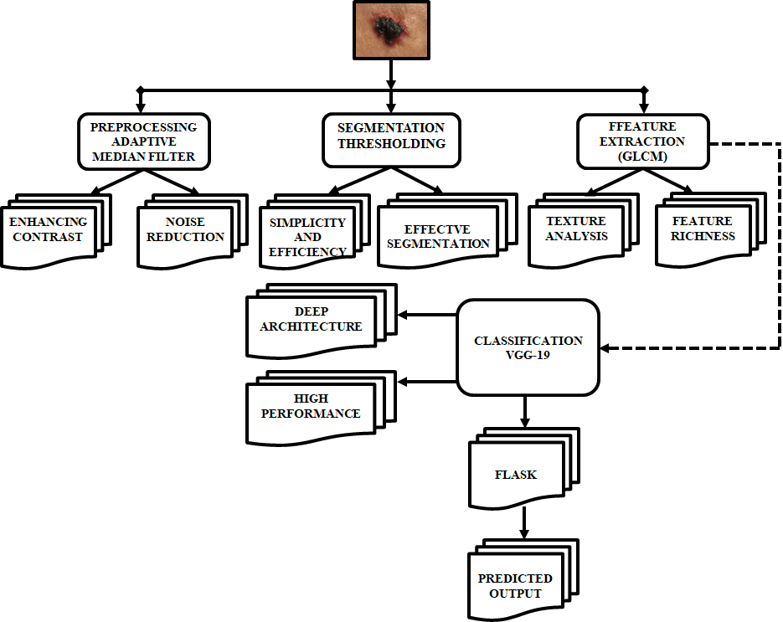

1. Block Diagram of Proposed System

### Pre-processing (Adaptive Median Filter-based)

In the Skin cancer prediction using Deep Learning, pre-processing is a crucial step to enhance the quality of the skin lesion image before feature extraction and classification. This stage utilizes Adaptive Median Filter to detect and describe key features within the skin cancer. The first step in pre-processing is denoising, where unwanted noise, such as distortions caused by hair, sweat which is removed to improve the image clarity. This ensures that the ridge patterns and minutiae points remain distinct and well-defined. Next, the image undergoes resizing, where it is adjusted to a standard dimension to maintain uniformity across the dataset. Standardizing the image size is essential for consistent feature extraction and ensures that the machine learning model processes all inputs in a uniform manner. These pre-processing steps help optimize the skin lesion image for subsequent segmentation and classification, ultimately improving the accuracy and reliability of skin cancer prediction.

### Segmentation (Thresholding)

In the Skin cancer prediction using Deep Learning, **segmentation** is a critical step that focuses on identifying and isolating the lesion (i.e., the area of interest) from the rest of the image, such as the surrounding healthy skin. Proper segmentation is essential for accurate feature extraction and classification, especially since irregularities in the lesion's shape, texture, and borders play a significant role in distinguishing benign from malignant growths. Simple thresholding involves selecting a pixel intensity threshold to separate the lesion from the background. Effective segmentation enhances the precision of feature extraction and classification, contributing to a more reliable deep learning model for skin cancer prediction.

### Feature Extraction (GLCM- Gray-Level Co-occurrence Matrix)

GLCM is a statistical method of examining the spatial relationship of pixels in an image. It provides a matrix representation of how often pairs of pixel with specific values (gray levels) occur in a specified spatial relationship. For texture analysis, it captures information about the spatial arrangement of pixels based on their gray levels. Feature extraction using the **Gray-Level Co-occurrence Matrix (GLCM)** is a well-known method in image processing, particularly for texture analysis. In the context of skin cancer detection, feature extraction is a critical step where GLCM is used to extract texture features that provide valuable information for distinguishing between benign and malignant lesions. In skin cancer detection, GLCM features are particularly useful because they characterize the texture of skin lesions, which is an important distinguishing factor in malignancy. For example:

**Benign lesions** tend to have smoother, more homogeneous textures, which result in lower contrast and entropy.

**Malignant lesions** often exhibit more irregular, heterogeneous textures, leading to higher contrast and entropy values.

Extract texture features like contrast, correlation, energy, homogeneity, entropy, and dissimilarity from the GLCM. This step ensures that only relevant and meaningful patterns are utilized, enhancing the accuracy of the classification model.

5) GLCM Features for Skin Cancer Detection

Several features be derived from the GLCM, including:

**Contrast**:

Measures the intensity contrast between a pixel and its neighbour over the whole image. High contrast suggests a rough, varied texture, whereas low contrast indicates a more uniform texture.

**Correlation**:

Describes how correlated a pixel is to its neighbour. It captures the linear dependence of gray levels in the GLCM.

**Energy (Angular Second Moment)**:

Measures the uniformity of the image texture. High energy corresponds to a homogeneous texture, while low energy indicates a more heterogeneous texture.

**Homogeneity**:

Measures the closeness of the distribution of elements in the GLCM to the GLCM diagonal. Homogeneous textures have pixel pairs that are similar, while more varied textures have pixel pairs that are more different.

**Entropy**:

Measures the randomness or disorder in the image texture. High entropy suggests a more complex or irregular texture, while low entropy indicates a more regular or uniform texture.

**Dissimilarity**:

Measures the variation in pixel pairs in the image. High dissimilarity values suggest that the texture is more complex, while low values indicate a smoother texture.

**Classification (VGG-19 Model)**

In the skin cancer prediction using Deep Learning, the classification stage plays a crucial role in determining the skin cancer based on extracted features. The processed features are fed into VGG-19, a powerful deep learning model known for its scalability and accuracy in image classification tasks. VGG-19 optimizes the learning process by balancing model depth, width, and resolution, ensuring efficient computation without compromising accuracy. The optimization helps to improve the model’s ability to differentiate subtle biometric characteristics linked to blood group prediction. Flask is a lightweight and easy-to-use Python web framework that is commonly used for building web applications and RESTful APIs. It's particularly popular for small to medium-scale projects due to its simplicity and flexibility. The classification step ultimately outputs the predicted cancer type offering a non-invasive and automated method that leverages deep learning for medical applications.

## Predicted Output Generation

In the skin cancer prediction using Deep Learning, the final step is predicted output generation, where the trained model determines the cancer type based on the extracted skin cancer features. After undergoing pre-processing, segmentation, and feature extraction, the refined data is fed into the VGG-19 classification model. Using its trained knowledge from previously analysed skin cancer correlations, the model processes the input lesion features and assigns the most probable skin cancer category. The output is generated in real-time, providing a rapid and non-invasive alternative to traditional blood tests. This prediction be further refined through continuous model training with diverse datasets to enhance its accuracy. The successful implementation of this step enables an integration of biometric-based blood group detection in medical diagnostics, emergency healthcare and forensic applications.

# Results and Discussion

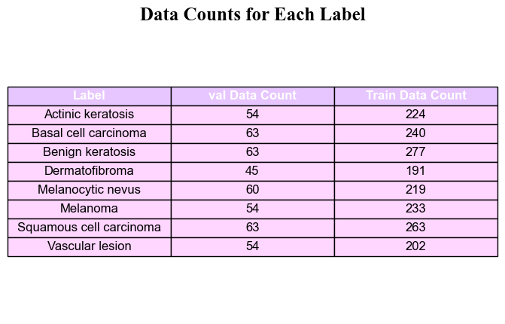

1. Data Counts for Each Label

Figure 2 presents the dataset distribution for different skin lesion types, showing validation and training data counts for each category. It includes conditions like melanoma, basal cell carcinoma, and benign keratosis, useful for skin lesion classification tasks.

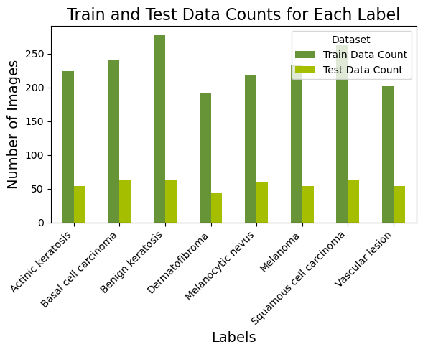

1. Train and Test Data Counts for Each Level

Figure 3 shows, the distribution of training and test data for different skin lesion types, with a higher number of training images compared to test images for each category. This dataset helps in developing machine learning models for skin lesion classification.

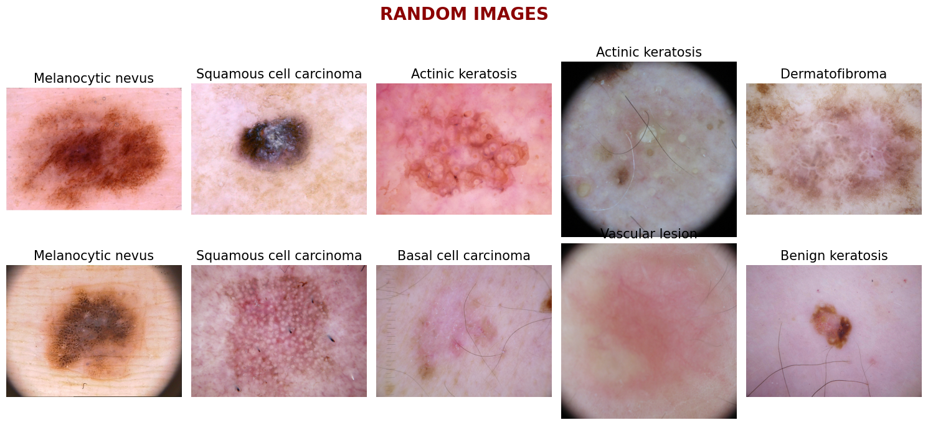

1. Skin Lesion Images

Figure 4 shows, various types of skin lesions, including melanocytic nevus, squamous cell carcinoma, actinic keratosis, and others, used for classification tasks. These samples help in training AI models for accurate skin disease diagnosis.

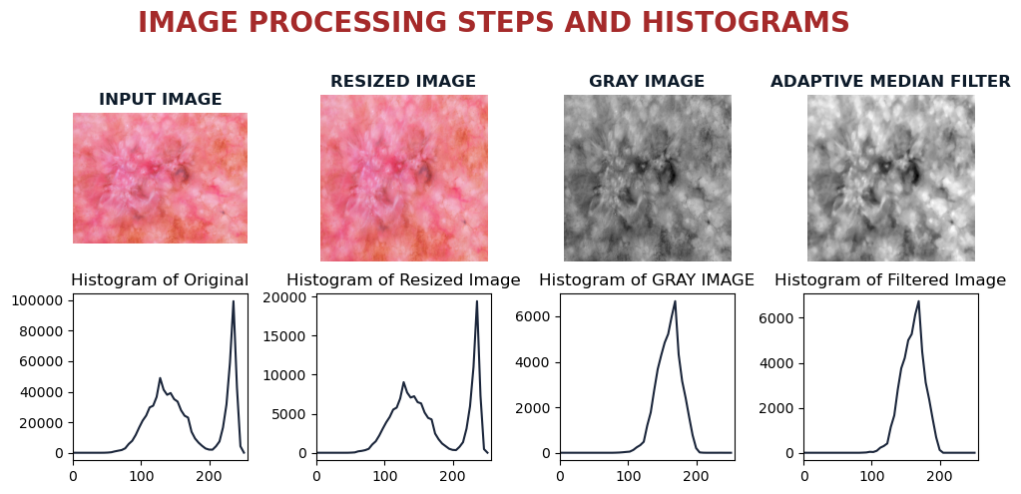

1. **Figure 5** Image Processing Steps and Histograms

Figure 5 illustrates key preprocessing steps in skin lesion analysis, including resizing, grayscale conversion, and adaptive median filtering, along with their corresponding histograms. These steps enhance image quality for accurate skin disease classification.

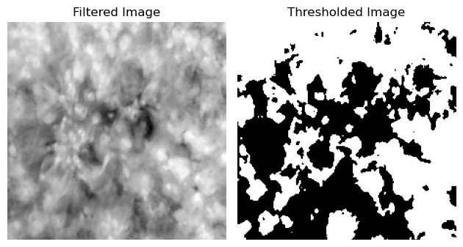

1. Filtered Image to Thresholded Image

Figure 6 shows skin lesion preprocessing steps, where the filtered image enhances details, and the thresholded image segments the lesion by separating foreground and background. These steps aid in feature extraction for accurate lesion classification.

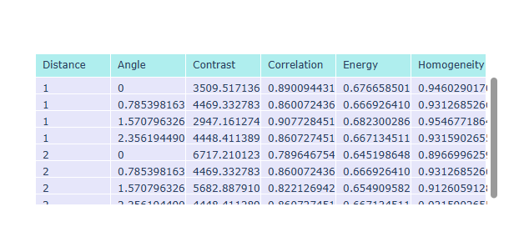

1. GLCM Texture Features Table

Figure 7 represents texture features extracted from skin lesion images using the Gray Level Co-occurrence Matrix (GLCM), including contrast, correlation, energy, and homogeneity. These features help in classifying skin lesions as benign or malignant.

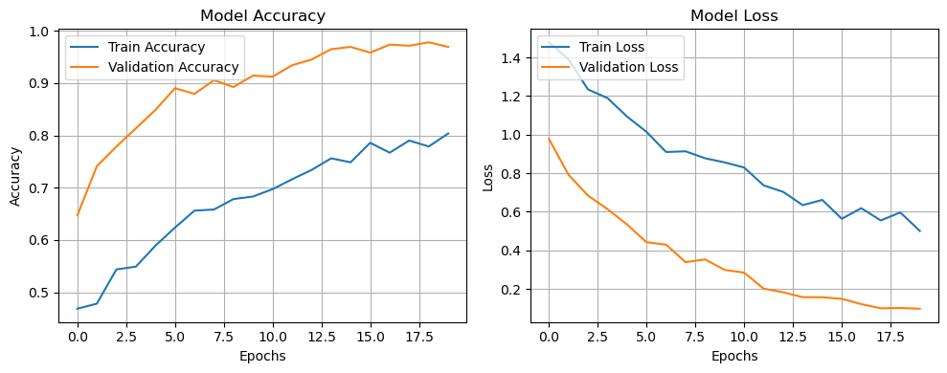

1. Model Accuracy and Model Loss

Figure 8 shows the training progress of a skin lesion classification model. The increasing validation accuracy and decreasing validation loss indicate effective learning, but the gap suggests potential overfitting.

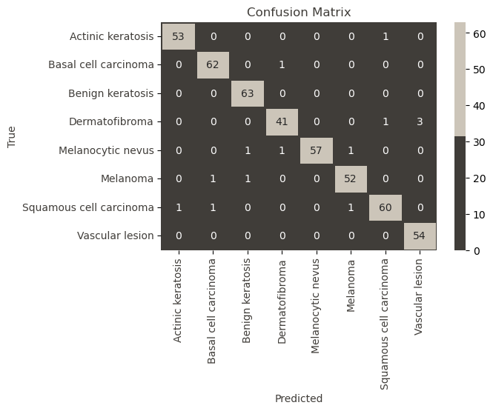

1. Confusion Matrix

Figure 9 evaluates the skin lesion classification model's performance, showing true vs. predicted labels. High diagonal values indicate good classification accuracy, with minimal misclassifications.

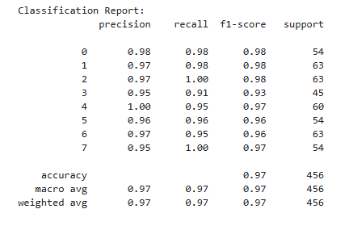

1. Classification Report

Figure 10 shows the skin lesion model's performance, with high precision, recall, and F1-scores across all classes. The overall accuracy of 97% indicates strong classification capability.

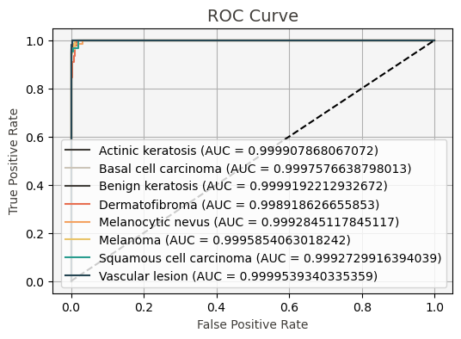

1. ROC Curve

Figure 11 shows excellent classification performance for skin lesion detection, with AUC values near 1 for all classes. This indicates high sensitivity and specificity in distinguishing different lesion types.



1. Home Page

Figure 12 predicts the skin lesion as melanoma, indicating a high-risk classification requiring further medical evaluation. The interface presents the processed lesion image with the diagnosis for user interpretation.

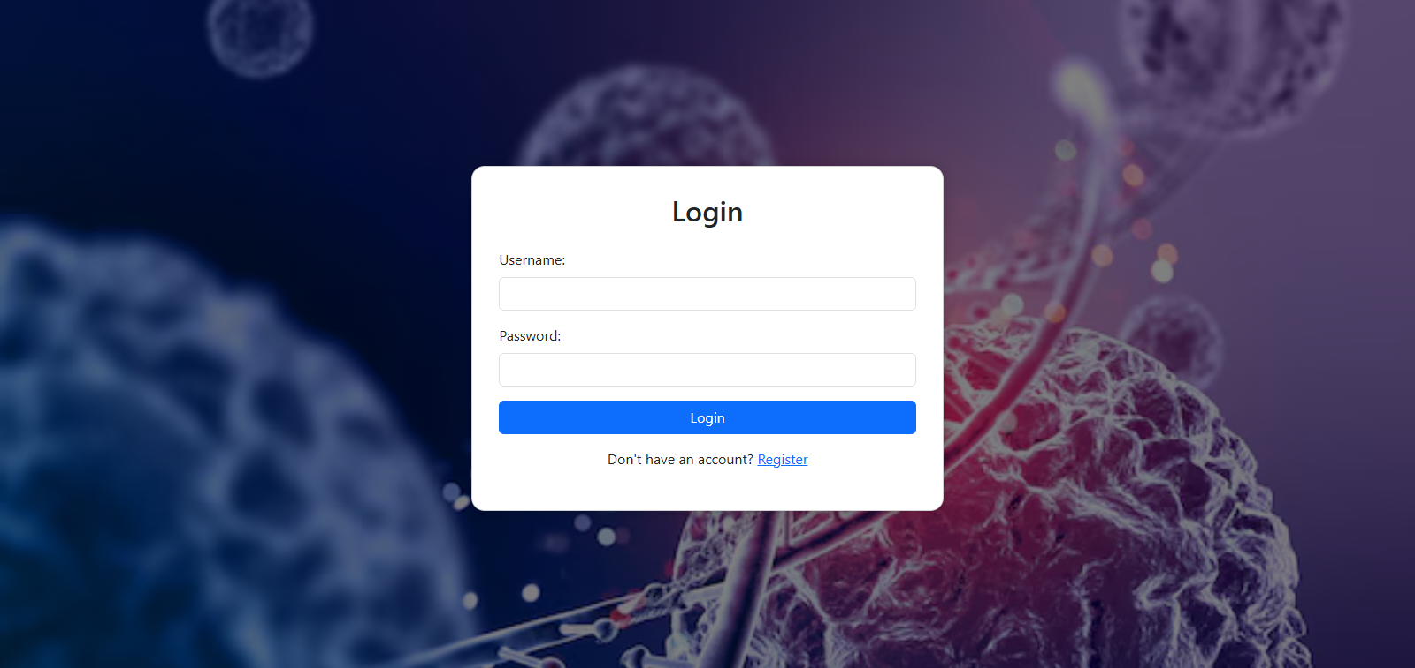

1. Login Page

Figure 13 shows a login page for a web-based medical or scientific platform. Users can enter their username and password to log in, or click Register to create an account. The background, featuring DNA and cells, suggests the platform is likely used for biomedical or diagnostic applications.

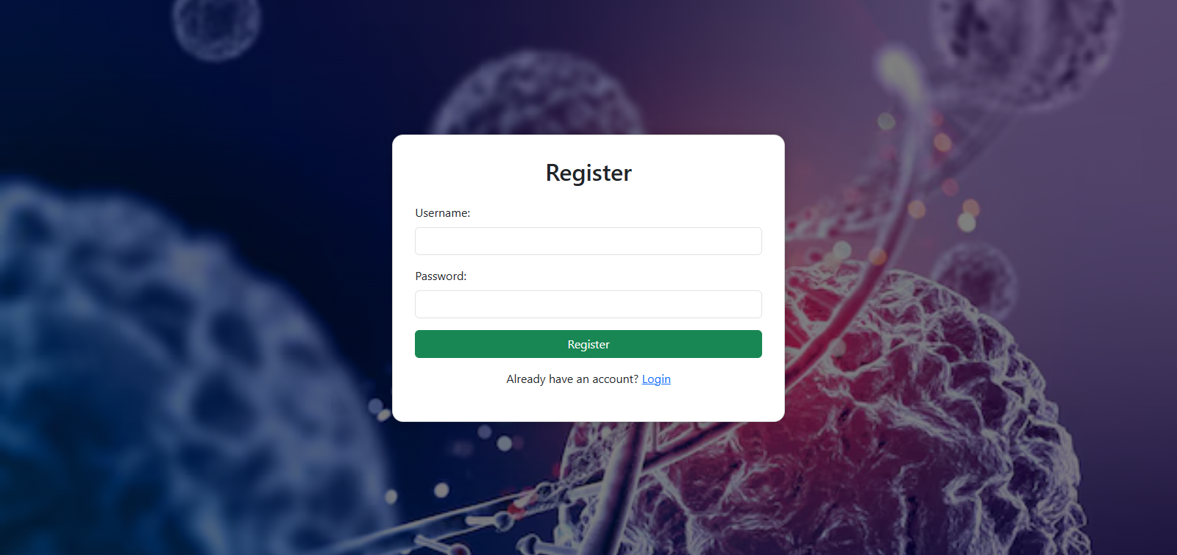

1. Register Page

Figure 14 predicts a registration page for a biomedical platform. Users can enter a username and password to create an account. A login link is provided for existing users. The DNA and cell background suggests it's for medical or scientific use.

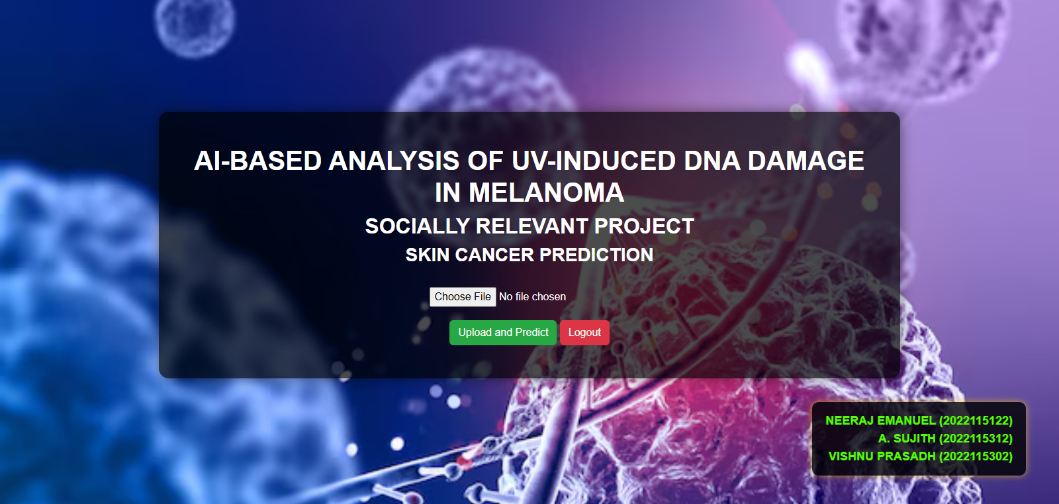

1. Analysis Page

Figure 15 predicts the user interface of an AI-based project titled AI-BASED ANALYSIS OF UV-INDUCED DNA DAMAGE IN MELANOMA, categorized as a SOCIALLY RELEVANT PROJECT for SKIN CANCER PREDICTION. The interface has options to Choose File for input, an Upload and Predict button, and a Logout button.

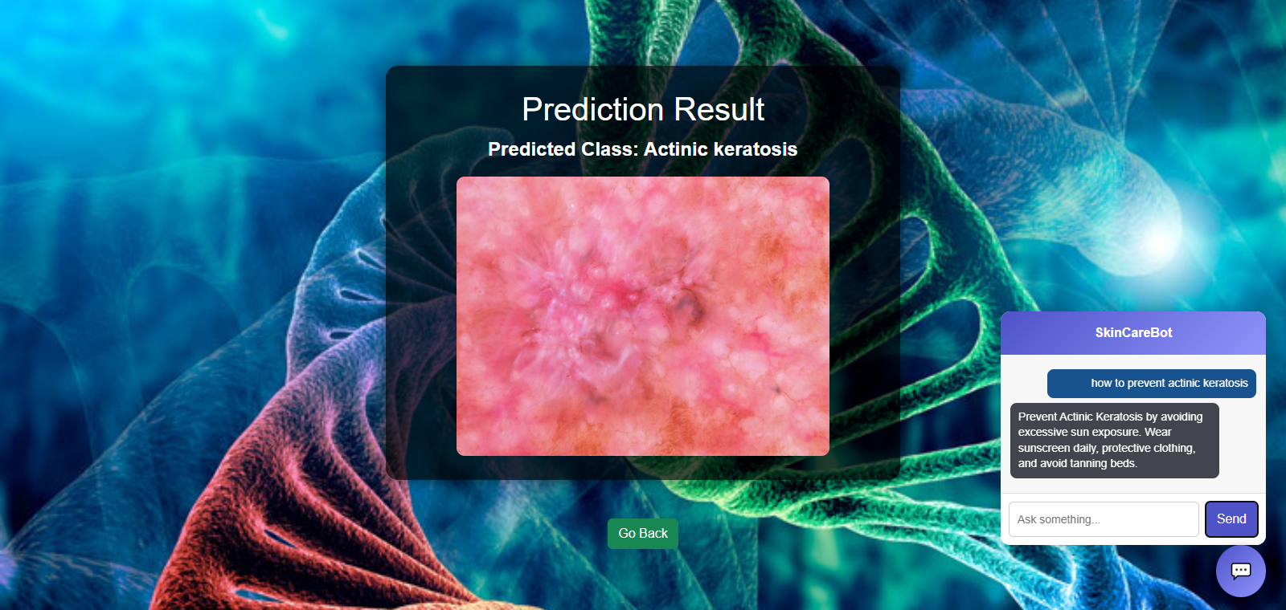

1. Result Page

Figure 16 predicts the prediction result for a skin condition, identifying Actinic keratosis. A zoomed-in lesion image is displayed, with a Go Back button below. On the right, a SkinCareBot offers prevention tips like using sunscreen and avoiding tanning beds and includes an input field for user queries. A DNA-themed background reflects the biological focus.

# Conclusion

In conclusion, this study presents a comprehensive AI-driven framework for the early detection and classification of skin cancer, with a particular focus on melanoma, by analyzing UV-induced DNA damage. The proposed system integrates multiple advanced techniques to enhance diagnostic accuracy and efficiency. Adaptive Median Filtering is employed as a preprocessing step to reduce noise while preserving essential features, ensuring that image quality is optimal for subsequent analysis. Thresholding-based segmentation is then applied to simplify the image structure, making it easier to isolate key areas of interest for classification. For feature extraction and classification, the model utilizes VGG19, a deep learning architecture known for its high accuracy in image recognition tasks. This allows the system to effectively distinguish between various skin conditions and provide reliable predictions. Additionally, Gray Level Co-occurrence Matrix (GLCM) texture analysis is incorporated to further refine feature extraction by analyzing texture patterns, leading to improved differentiation between benign and malignant skin lesions.

To ensure real-time and user-friendly deployment, the framework is implemented using Flask, a lightweight web application framework that enables seamless interaction between users and the AI model. This allows medical professionals and patients to upload images, receive instant diagnostic feedback, and access the results in a convenient manner. The proposed approach significantly reduces reliance on manual interpretation by dermatologists, streamlining the diagnostic process and increasing the speed of early detection. The experimental results of this study validate the effectiveness of the framework, demonstrating its capability to accurately classify skin diseases and contribute to timely medical intervention. By leveraging AI and deep learning techniques, this system aims to automate skin cancer detection, enhancing accessibility, efficiency, and accuracy in dermatological diagnostics.

# FUTURE WORK

* Future iterations of this system could incorporate state-of-the-art transformer-based models, such as Vision Transformers (ViT) and Swin Transformers, which have demonstrated superior performance in image classification tasks. These models offer self-attention mechanisms that allow them to focus on important regions of an image, improving feature learning and classification accuracy. By leveraging these architectures, the model could achieve greater generalizability, minimizing errors and improving diagnostic precision, especially for complex skin conditions.
* Combining dermoscopic images with patient medical history, genetic data, and UV exposure levels could lead to a more comprehensive and personalized risk assessment. Deep learning models trained on multi-modal data identify patterns that would otherwise be undetectable in single-modality approaches. This holistic diagnostic approach could help in assessing a patient’s predisposition to melanoma and other skin diseases, leading to early interventions and more effective treatment planning.
* A major challenge in AI-based healthcare applications is the black-box nature of deep learning models. To address this, Explainable AI (XAI) techniques be integrated into the system to provide interpretable and transparent predictions. Techniques such as Grad-CAM (Gradient-weighted Class Activation Mapping) and SHAP (SHapley Additive exPlanations) visually highlight the regions of an image that influenced the AI’s decision. This level of interpretability would help dermatologists validate predictions, increase trust in AI recommendations, and support collaborative decision-making between healthcare professionals and AI systems.
* To establish the model’s clinical credibility, collaboration with dermatologists, oncologists, and hospitals is essential. Conducting large-scale clinical trials would provide valuable real-world insights, helping refine the model’s predictions and ensuring reliability in diverse patient populations. Integrating the AI system into dermatology clinics and hospitals would allow it to be tested on varied skin types, age groups, and geographical regions, ensuring that the model is robust and unbiased.

##### Acknowledgment

We thank our mentors Dr Thangaraj and Dr Arul Deepa for their constructive feedbacks, helpful suggestions and guidance throughout the tenure of our project.

##### References

1. K. Mridha, M. M. Uddin, J. Shin, S. Khadka and M. F. Mridha, "An Interpretable Skin Cancer Classification Using Optimized Convolutional Neural Network for a Smart Healthcare System," in IEEE Access, vol. 11, pp. 41003-41018, 2023.
2. N. Shafi et al., "A Portable Non-Invasive Electromagnetic Lesion-Optimized Sensing Device for the Diagnosis of Skin Cancer (SkanMD)," in IEEE Transactions on Biomedical Circuits and Systems, vol. 17, no. 3, pp. 558-573, June 2023.
3. M. N. Hamza, M. Tariqul Islam, S. Lavadiya, S. Koziel, I. Ud Din and B. Cavalcante de Souza Sanches, "Designing a High-Sensitivity Dual-Band Nano-Biosensor Based on Petahertz MTMs to Provide a Perfect Absorber for Early-Stage Nonmelanoma Skin Cancer Diagnostic," in IEEE Sensors Journal, vol. 24, no. 11, pp. 18418-18427, 1 June1, 2024.
4. R. Karthik, R. Menaka, S. Atre, J. Cho and S. Veerappampalayam Easwaramoorthy, "A Hybrid Deep Learning Approach for Skin Cancer Classification Using Swin Transformer and Dense Group Shuffle Non-Local Attention Network," in IEEE Access, vol. 12, pp. 158040-158051, 2024.
5. W. Di, F. Xin, L. Yu, Z. Hui, H. Ping and S. Hui, "ECRNet: Hybrid Network for Skin Cancer Identification," in IEEE Access, vol. 12, pp. 67880-67888, 2024.
6. I. Ahmed, B. Bushon Routh, M. S. Rahman Kohinoor, S. Sakib, M. Mahfuzur Rahman and F. Azzedin, "Multi-Model Attentional Fusion Ensemble for Accurate Skin Cancer Classification," in IEEE Access, vol. 12, pp. 181009-181024, 2024.
7. Z. Ji, X. Wang, C. Liu, Z. Wang, N. Yuan and I. Ganchev, "EFAM-Net: A Multi-Class Skin Lesion Classification Model Utilizing Enhanced Feature Fusion and Attention Mechanisms," in IEEE Access, vol. 12, pp. 143029-143041, 2024.
8. Y. Olmez, G. O. Koca, A. Sengür, U. R. Acharya and H. Mir, "Improved PSO With Visit Table and Multiple Direction Search Strategies for Skin Cancer Image Segmentation," in IEEE Access, vol. 12, pp. 840-867, 2024.
9. X. Qian et al., "SPCB-Net: A Multi-Scale Skin Cancer Image Identification Network Using Self-Interactive Attention Pyramid and Cross-Layer Bilinear-Trilinear Pooling," in IEEE Access, vol. 12, pp. 2272-2287, 2024.
10. S. Chatterjee, J. -M. Gil and Y. -C. Byun, "Early Detection of Multiclass Skin Lesions Using Transfer Learning-Based IncepX-Ensemble Model," in IEEE Access, vol. 12, pp. 113677-113693, 2024, doi: 10.1109/ACCESS.2024.
11. P. M. Conforti, G. Lazzini, P. Russo and M. D’Acunto, "Raman Spectroscopy and AI Applications in Cancer Grading: An Overview," in IEEE Access, vol. 12, pp. 54816-54852, 2024.
12. M. Gallazzi, S. Biavaschi, A. Bulgheroni, T. M. Gatti, S. Corchs and I. Gallo, "A Large Dataset to Enhance Skin Cancer Classification With Transformer-Based Deep Neural Networks," in IEEE Access, vol. 12, pp. 109544-109559, 2024.
13. S. Remya, T. Anjali and V. Sugumaran, "A Novel Transfer Learning Framework for Multimodal Skin Lesion Analysis," in IEEE Access, vol. 12, pp. 50738-50754, 2024.
14. S. S. Reka, H. L. Karthikeyan, A. J. Shakil, P. Venugopal and M. Muniraj, "Exploring Quantum Machine Learning for Enhanced Skin Lesion Classification: A Comparative Study of Implementation Methods," in IEEE Access, vol. 12, pp. 104568-104584, 2024.
15. M. Rezeg, A. Hlali and H. Zairi, "THz Biomedical Sensing for Early Cancer Detection: Metamaterial Graphene Biosensors With Rotated Split-Ring Resonators," in IEEE Photonics Journal, vol. 16, no. 4, pp. 1-10, Aug. 2024.
16. M. F. Almufareh, "Unveiling the Spectrum of UV-Induced DNA Damage in Melanoma: Insights from AI-Based Analysis of Environmental Factors, Repair Mechanisms, and Skin Pigment Interactions," in IEEE Access, vol. 12, pp. 64837-64860, 2024.
17. S. Ibrahim, K. M. Amin, R. Ibrahim Alkanhel, H. A. Abdallah and M. Ibrahim, "Soft Attention Based Efficientnetv2b3 Model for Skin Cancer’s Disease Classification Using Dermoscopy Images," in IEEE Access, vol. 12, pp. 161283-161295, 2024, doi: 10.1109/ACCESS.2024.
18. S. Feng, X. Chen and S. Li, "Wavelet Guided Visual State Space Model and Patch Resampling Enhanced U-Shaped Structure for Skin Lesion Segmentation," in IEEE Access, vol. 12, pp. 181521-181532, 2024, doi: 10.1109/ACCESS.2024.
19. V. S. S. B. T. Sathvika et al., "Pipelined Structure in the Classification of Skin Lesions Based on AlexNet CNN and SVM Model With Bi-Sectional Texture Features," in IEEE Access, vol. 12, pp. 57366-57380, 2024, doi: 10.1109/ACCESS.2024.
20. H. Amjad et al., "Precision Segmentation and Binary Masking of Skin Lesions in Automated Dermatological Diagnostics Using Detectron2," in IEEE Access, vol. 12, pp. 187696-187708, 2024.